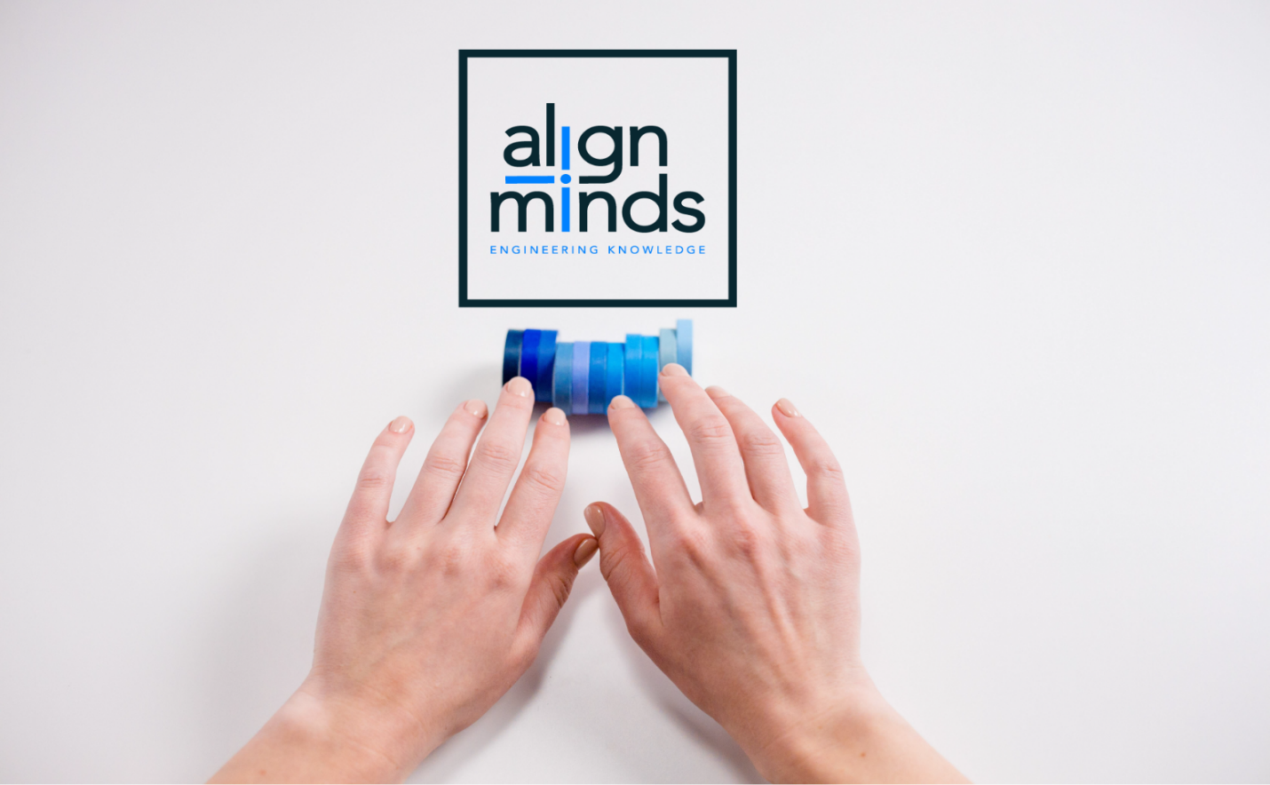
Proposal For Design and Development of
Motor Insurance Workflow Automation – MVP
for Ahalia Insurance Services Pvt. Ltd


Dec 30, 2025
CLNT/30122025
[FILL HERE]

Contents
1 About Us 4
1.1 Background 4
1.2 Our Mission 4
1.3 Services 5
1.4 Clients 6
1.5 Testimonials 7
2 Executive Summary 8
3 Project Overview 8
3.1 Client Requirements 9
4 Proposed Solution 9
4.1 Functional Requirements 10
4.2 Non-Functional Requirements 10
5 Technical Architecture 11
5.1 High Level Architecture Diagram 11
6 Technology Stack And Development Process 12
6.1 Technology Stack 12
6.2 Detailed Motor Insurance Workflow with Technology Mapping 12
7 Development Process 13
8 Automation Levels & Human-in-the-Loop (HITL) Points 16
9 IRDAI Compliance Alignment 16
10 Future 100% API-Based Automation Path 17
11 Proposed Team 17
12 Out Of Scope and Assumptions 18
12.1 Out of scope 18
12.2 Assumptions 19
13 Cost Model – Implementation & Operations 20
14 Warranty and Maintenance 20

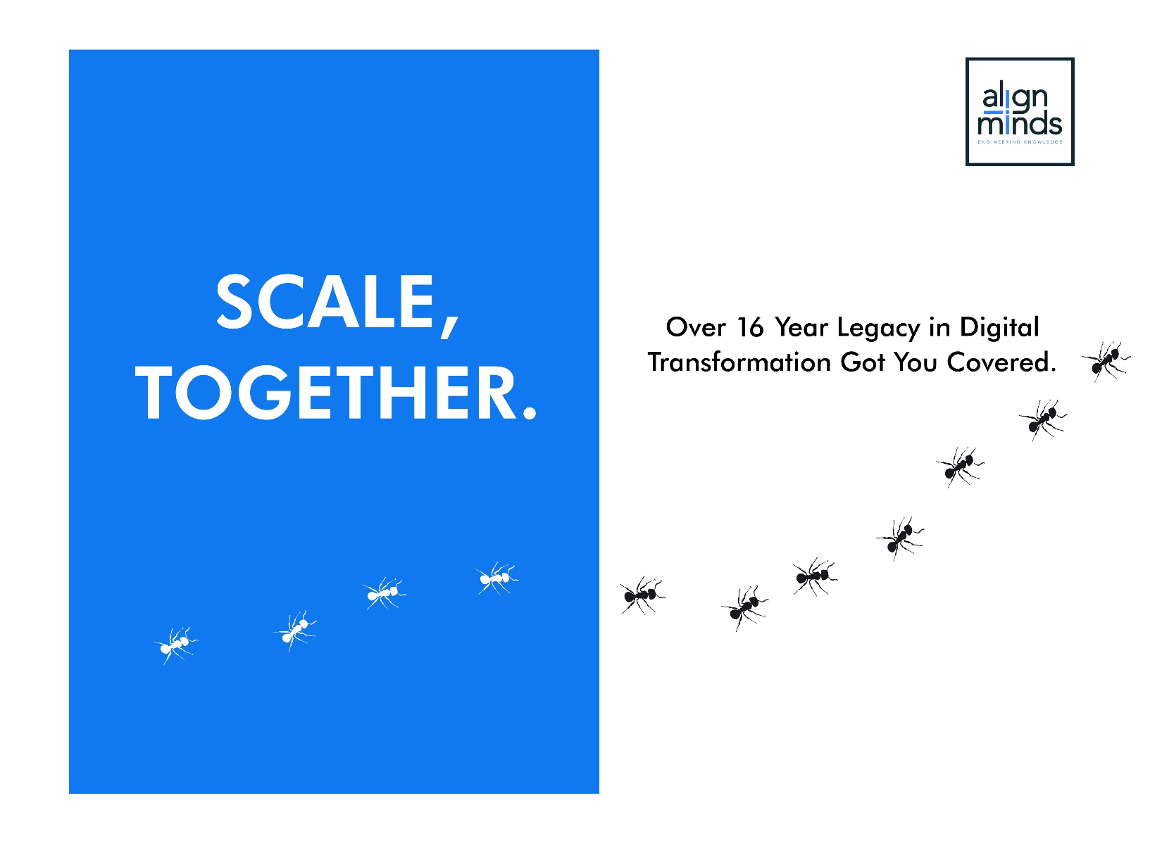

Background
[FILL HERE]
 | PRODUCT ENGINEERING  [FILL HERE]
 | PRODUCT MODERNIZATION  Infuses age-old products with the brilliance of modern UI/UX, transformative architectures, AI touchpoints, and cloud metamorphosis.
 | ARTIFICIAL INTELLIGENCE  With capabilities in Computer Vision and Generative AI, we not only shape solutions that perceive, interpret, and innovate but also seamlessly integrate AI capabilities into existing applications.
 | CLOUD AND DEVOPS  Transitioning effortlessly through Cloud Migrations, optimizing resources, integrating DevOps, we construct a digital backbone that stands strong, secure, and adapts seamlessly to your dynamic needs.
 | DEDICATED PRODUCT DEVELOPMENT TEAMS  Hire expert software engineering teams with niche skills and great communication.
 |  | 
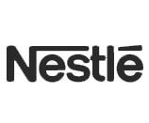 |  | 
 |  | 

Executive Summary
[FILL HERE]
Resource Role | Month 1 | Month 2 | Month 3
Solution Architect | 0.5 | 0.25 | 0.25 | 0.1
Power Automate Lead | 1.0 | 1.0 | 0.75 | 0.5
RPA Developer 1 | 1.0 | 1.0 | 1.0 | 0.75
RPA Developer 2 | 1.0 | 1.0 | 1.0 | 0.75
Azure AI / Doc Engineer | 0.5 | 0.5 | 0.25 | 0.1
QA / UAT Engineer | 0.25 | 0.5 | 0.75 | 0.75
Azure / DevOps Engineer | 0.25 | 0.25 | 0.5 | 0.25
Project Manager | 0.5 | 0.5 | 0.5 | 0.5
A. Fixed One-Time Implementation Cost
Component | Duration | Cost  (USD)
Implementation Cost (Resource Cost) | 4 Months | 47,500.00
B. Annual Operational Cost (Post Go-Live)
Component | Estimated Monthly Cost (USD) | Estimated Annual Cost (USD)
1. Technology & Platform Costs (Annual)
Power Automate Process Licenses (Unattended Bots – 4) | 600.00 | 7,200.00
Power Automate Premium (1 User License) | 20.00 | 240.00
Azure Document Intelligence | 3.00 | 36.00
Azure Virtual Machines (Bot Runners) | 31.00 | 372.00
Azure Storage, Key Vault, Monitoring | 0.03 | 0.36
Micorosoft 365 | 6.00 | 72.00
Technology Subtotal (1) | 660.00 | 7,920.00
2. Operational Support Costs (Annual)
Bot Monitoring & Support (10 mandays/month) | 1,250 | 15,000
Operations Subtotal (2) | 1,250 | 15,000
Total Annual Operational Cost (1 + 2) | 1,910.00 | 22,920.00

